Git Repo Link:  
https://github.com/KeerthanaGarimella/InclassTask-3

Output in terminal:

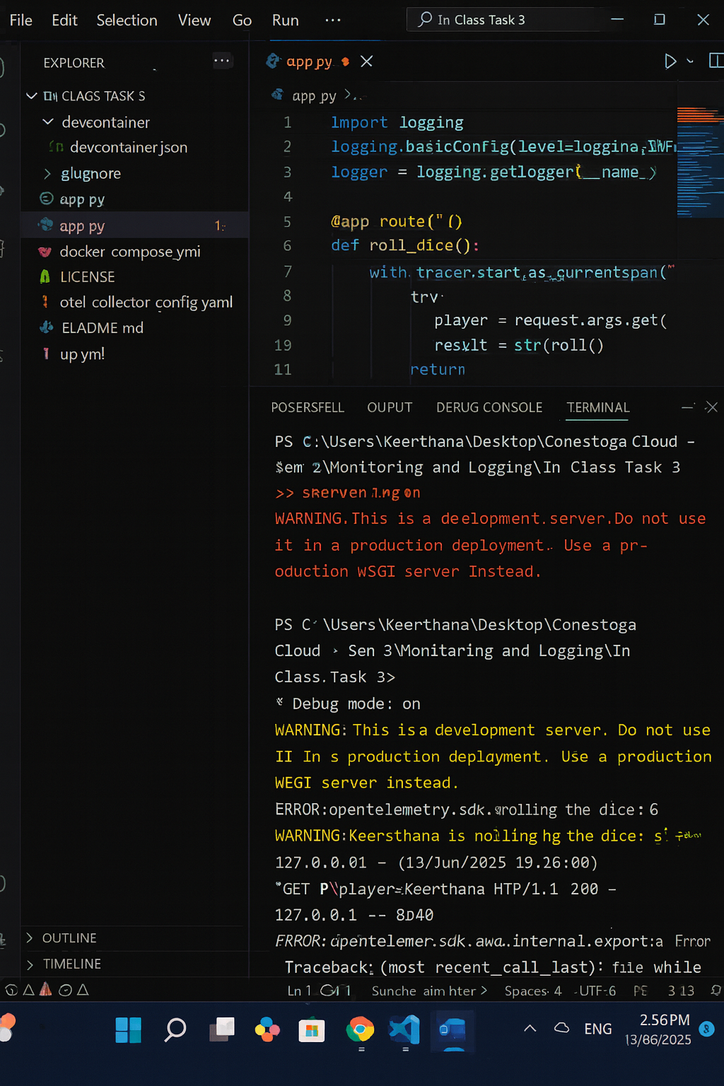

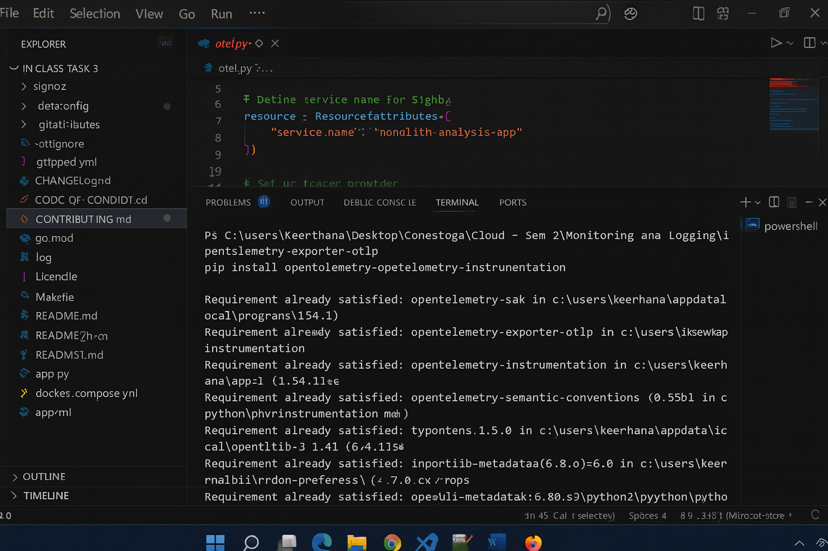

Output In Browser:

Trace:

Exception:

